East Asian Consortium on Biomedical Engineering Student Workshop Proceedings
35mm
27mm
20mm
25mm
20mm
20mm

Instructions for Authors

Taro Tohoku^{*1)}, Hanako Aoba¹⁾, and Jiro Hirose²⁾
1) Institution/Department, Affiliation
2) Institution/Department, Affiliation
E-mail: tarotohoku@aoba.mech.tohoku.ac.jp

Pages, Size, Numbers, Fonts

Use A4 size paper, Use Microsoft Word. File name: control ID. Only even number of pages. Top and both side margins should be set to 20 mm and the bottom margin should be 25mm throughout the manuscript. No page numbering, header, footer should be used. Times New Roman font or equivalent should be used (for point size see section 4).

1. Construction of Papers

Abstract,
1. Introduction
2. Methods
3. Results
4. …
5. Conclusion
Acknowledgements
References
(Note) Abstract, Acknowledgements, and References sections should not be numbered

2. Title
2.1. Title, author name(s), affiliation(s)

The article title should be in bold format 16pt. Capitalize each word, except articles (a, an, the), conjunctives (while, and, using, …), and prepositions (of in, by, to,…). Top of the hyphenated words should only be capitalized. Line spacing should be 18pt.

(Eg.)

Neuronal Activity in the Supplementary Eye Field during an Oculomotor Set-shifting Task

Author names should be in 12pt and spaced 24pt, arranged in the order of the first name, initials of middle names (if any), and the family name. The first and the family names should be capitalized. If there are only two authors, their names should be spaced by “and” without using a comma. If there are more than 3 authors, they should be punctuated by using commas, and an “and” should be placed between the one before last and the last. Principal author should be designated by using an asterisk (*).

(Eg.)
John A. Smith* and Steve K. Moore
Julio Garcia*, Mary Rose, and Toru Suzuki

3. Portrait (Photograph) of the Principal Author

Portrait photograph of 3.5cm x 2.7 cm (bust, color, with resolution of 300 pixel/inch) should be placed on the right of the title.

4. Main Body of Text

Font: Times New Roman, 10pt with line spacing 12pt.
Two blank lines (10pt fonts, 12 pt line space) below the e-mail address.
The main body of the text should be formatted into two columns, both side flushed, and space between two columns should be 10mm.
Indent one character at each paragraph.
Headings, such as Abstract, 1.Introduction,…, should be in 11pt bold. Following numbering system should be used. Capitalize only the first word of headings.

(Eg.)

2. Measurement Coupled Simulation of Blood Flows
2.1. Mouse treatments
2.2. Mutation analysis
2.2.1. Geometry of the artery model

5. Figures, Photographs, Tables

Figures and photographs should be numbered in the order of their appearance, such as Fig. 1, Fig. 2 (Not Photo.1 etc). Figure captions should be placed just beneath it, with the same width, center-flushed, in 10pt, the first word should be captalised. Tables should be numbered same way, Table 1, Table 2, …. Table captions must appear immediately above the table, with the same width, and center-flushed.
Colour figures and photographs can be printed as is.
Letters in the figures, photographs, and tables must be larger than 6pt when it is printed.

(Eg.)
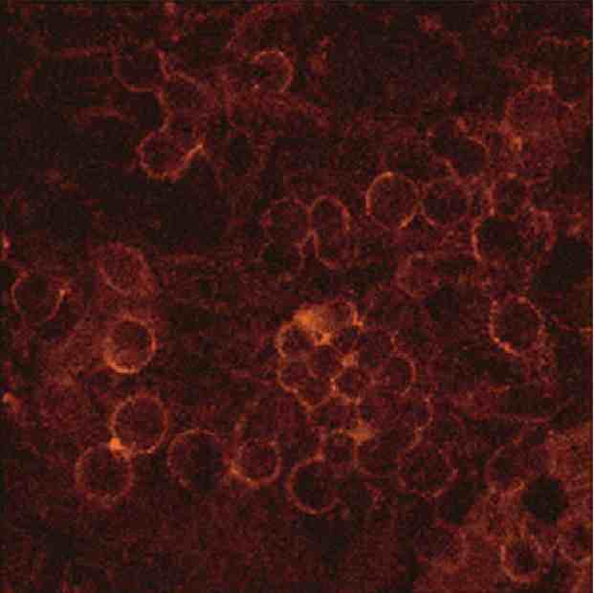
Fig. 1. Figure caption

Table 1. Table caption

Table legend
Table data

6. Mathematical Expressions

Mathematical expressions should be sequentially numbered at the right margin of the line using parenthesis, such as (1), (2),….
When mathematical expressions appear in a sentence, it should be punctuated by comma, and if the expression is place at the end of a sentence, a full stop should follow it.
When the expression is mentioned in a main body of text, they should be referred in the form of Eq.(1), Eqs.(2) and (3)…

If the image files are used to format expressions, it should be separately submitted in a similar manner to the figures and photographs. Their file name should be EqXX_NameOfAuhors.extension. The resolution must be greater than 300 pixels./inch

(Eg.)
(1)

Acknowledgement (s)

Author supported by the Tohoku University Global COE Programme should be mentioned in the following manner;

XXX acknowledge(s) the support of Tohoku University Global COE Programme “Global Nano-Biomedical Engineering Education and Research Network Centre”. (XXX is the name(s) of author(s).)

References

All references should be listed at the end of the article numbered in the sequence of its appearance in the body of the text, using serial numbers such as [1], [2]…. Place the citation number in the form [1], [1,2], [1-3], [1-3,5]… where it is cited.

Format of the citation;
[Number] First Author, Second Author, and Third Author.(full stop) (space) Article Title (full stop) (space) Journal Name (italic, follow the abbreviation of Medline) (space) Number of Volume (Bold), (comma) Begin Page –(hyphen) End Page, (comma) Year.(full stop)

Note for Author Name(s):
Family Name (in full) (space) Initials (Private and Middle Names) (comma) … (comma) and Last Author Name

(Eg.)
- DeBakey ME, Lawrie GM, and Glaeser DH. Patterns of atherosclerosis and their surgical significance. Ann Surg 201, 115-131, 1985.
- Ausubel FM, Brent R, Kingston RE, Moore DD, Seidman JG, Smith JA and Struhl K. Current Protocols in Molecular Biology. Wiley, New York, 25-26, 1995.

